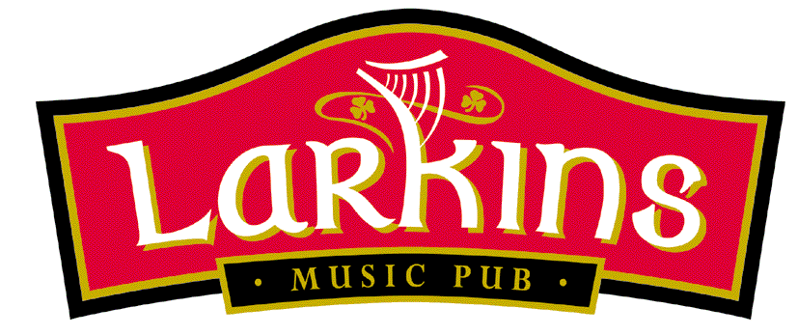
CHILDREN'S MENU
Soup €3.00
Sausages & Chips or Mash €5.95
Homemade Burger & Chips or Mash €6.50
Chicken Goujons & Chips or Mash €6.75
Crispy Fish Goujons & Chips or Mash €7.00
Penne with Tomato & Basil Sauce €5.00
with Chicken €6.00
Chicken Wings & Chips €6.95
Baby Bowl €3.00

SIDE ORDERS
Beans €1.50
Chips / Mash €2.50
Vegetables €2.50
Mixed Salad €2.50

DESSERTS
Ice Cream Cone/Tub
Small €2.50
Medium €3.50
Large €4.50
Hot Chocolate €3.00

