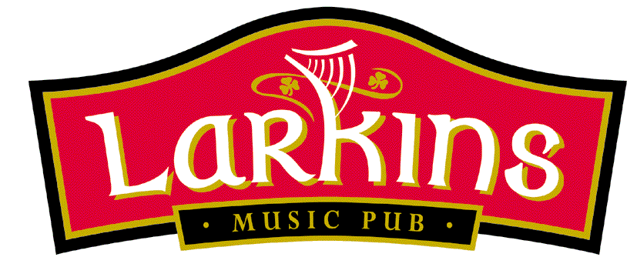
Welcome to Larkins, committed to supporting Irish Producers in the Irish Food Industry.
Before placing your order, please inform your server if a person in your party has a food allergy or food intolerance.
To Kick-off...
Atlantic Seafood Chowder €8.95
Served with homemade brown bread
Ardsallagh' Goats Cheese with Crostini, Roasted Peppers & Caramelised €9.95
Walnuts and Balsamic Vinegar
King Prawns Tempura, Roast Garlic, Tomato & Chili Salsa €9.95
Fresh Glenbeigh Mussels in a White Wine & Garlic Cream €9.95
Pan Fried Wild Mushroom Bruschetta with Creamy Garlic Sauce €7.95
Homemade Vegetable Soup €5.95
Served with homemade brown bread
Hot & Spicy Sticky Chicken Wings with a Chive Crème Fraiche €7.95
Prawn and Crabmeat Salad served with Marie Rose Sauce €8.95
'Inch House' Black Pudding Salad served with Apple Sauce €8.50
The Main Event...
Larkin’s Steak Burger served with Salad & Homemade Chips €13.95
100% Irish Mince Beef
Add Smokey Bacon & Monterey Jack Cheese €14.95
Chicken and Smokey Bacon Linguini in a Creamy Sauce €15.95
Served with Parmesan Cheese & Garlic Bread
Prime Irish Hereford Sirloin Steak €26.00
Cooked to your liking, served with roast tomato, crispy onion rings & chips
Choice of pepper sauce, garlic butter.
Roast Silverhill Duckling with Apricot Stuffing €26.00
Red Cabbage & Cointreau Sauce
Ruby Ale Battered Fish & Chips with Mushy Peas €15.95
Seafood Pie with Creamy Mash with a Mixed Salad €16.95
Fillet of Pork served with Smokey Bacon Mash & a Red Wine Jus €22.00
Baked Fillet of Hake with a Pesto Crumb €22.00
Served with a white wine Sauce
Larkin's Chicken Curry served with Rice and Naan Bread €16.00
Vegetable Linguini in a Creamy Sauce €12.50
Served with Garlic Bread and Parmesan Cheese

Side Orders:
Mixed Salad / Vegetables / Potatoes / Homemade Chips €3.50

